Botulinum Toxin Treatment of the Face and Neck- BOTOX

This consent form is designed to provide the information necessary when considering whether or not to undergo outline toxin treatment for facial and neck wrinkles with Botox.
Injection of Botulinum toxin (Botox) causes weakness of targeted muscles, which can last approximately 3-4 months. Injections of small amounts of Botox relaxes the treated muscles and can reduce facial wrinkles such as frown lines. Botox solution is injected with a small needle into the targeted muscles. Effects are typically seen in a few days and can take 1-2 weeks to fully develop.
Botox is approved by the FDA for the temporary treatment of moderate to severe dynamic frown lines in adults 18-65 years and is used off-label for all
other cosmetic treatment areas.
The risk, side effects, and complications in treatment with Botox on facial and neck areas include, but are not limited to the following:

1) Localized burning or stinging pain during injection
2) Bruising, Redness, Tenderness, Swelling, Infection, Numbness, Headache
3) Anxiety
4) Vasovagal episode (fainting) with loss of consciousness
5) Facial asymmetry (un-evenness) alteration or poor aesthetic result
6) Inadequate reduction of wrinkles or lack of intended effect
7) Blepharoptosis (droopy eyelid)
8) Eyebrow ptosis (droop eyebrow)
9) Photophobia (light sensitivity)
10) Impaired eyelid closure and blink reflex
11) Ectropian (lower eyelid exposure)
12) Lagophthalmos (incomplete eyelid closure)
13) Exophthalmia (dry eyes)
14) Epiphora (tearing)
15) Diplopia (double vision) or vision changes
16) Eye Trauma
17) Worsening eye bags
18) Lip ptosis with resultant smile asymmetry
19) Oral incompetence (lips apart) with resultant drooling and/or impaired speaking, eating, or drinking
20) Cheek Flaccidity
21) Dysarthria (difficulty articulating)

22) Dysphasia (difficulty swallowing), necessitating nasogastric tube placement in severe causes
23) Hoarseness
24) Neck weakness
25) Weakening of muscles adjacent to the intended treatment area
26) Auto-antibodies against outline toxin may be present or develop after treatments rendering treatments ineffective (1-2°/o of patients treated for cosmetic indications per Allergan).
27) Extremely rare, immediate hypersensitivity reaction with signs of uticaria, edema, and a remote possibility of anaphylaxis.
28) Case reports of side effects due to distant spread from the site of injection have been reported with large doses of botulinum toxin, including generalized muscle weakness, ptosis, dysphasia, dysarthria, urinary incontinence, respiratory difficulties, and death due to respiratory compromise
Post-marketing safety data suggest that botulinum toxin effects may, in
some cases, be observed beyond the site of local injection. The symptoms may include generalized muscle weakness, double vision, blurred vision, eyelid droop, difficulty swallowing, difficulty speaking, urinary incontinence, and breathing difficulties. These symptoms have been reported hours to weeks after injection. Swallowing and breathing difficulties can be life threatening and there have been reports of death related to spread of toxin effects. The risk of symptoms is probably greatest in children treated for plasticity but symptoms can also occur in adults, particularly in those patients who have underlying event reports of distant spread of toxin effect associated with dermatologic use of cosmetic botulinum toxin at the labeled dose of 20 units (for frown lines) or 100 units (for underarm sweating) have been reported.
My signature below certifies that I have fully read this consent form and understand the information provided to me regarding the propose procedure. I have been adequately informed about the procedure including the potential benefits, limitations, and alternative treatments, and I have had all questions and concerns answered to my satisfaction. I understand that results are not guaranteed and I accept the risks, side effects, and possible complication inherent in undergoing Botox treatments.

Patient Name: -----------------------------
Patient Signature: -------------------- Date: _

AAFE AMERICAN ACADEMY OF FACI AL tsTHETICS
2120 South Green Road.Second Floor
South Euclid.OH 44121

800.952.0521 I WWW.FACIAL£STHETICS.ORG

-·---- - --- ------ -------- - -

Patient Name

History of recent NSAID: Y ;::) N 0 Pregnant: Y 0 N 0

Significant Medical History -- ------ - - - -

Date-- - ------ ------· - Patient initials
Current Medical History-------

TRED,Tiv1ENT HiSTORY -

Patient's first Dermal filler treatment: Y ..) N CJ
Previous Dermal filler problems? Date of last Dermal filler treatment
Patient's first Botox trea tment: Y ..) N ::J
Previous Botox problems? - -- -- ---- Date of last Botox treatment

Off label consent given ------ ..
Off label consent given------- --

Informed consent given.. .•
_ _ _
Informed consent given - - - --- - --

Muscle Dosage Syringe
i Frontalis
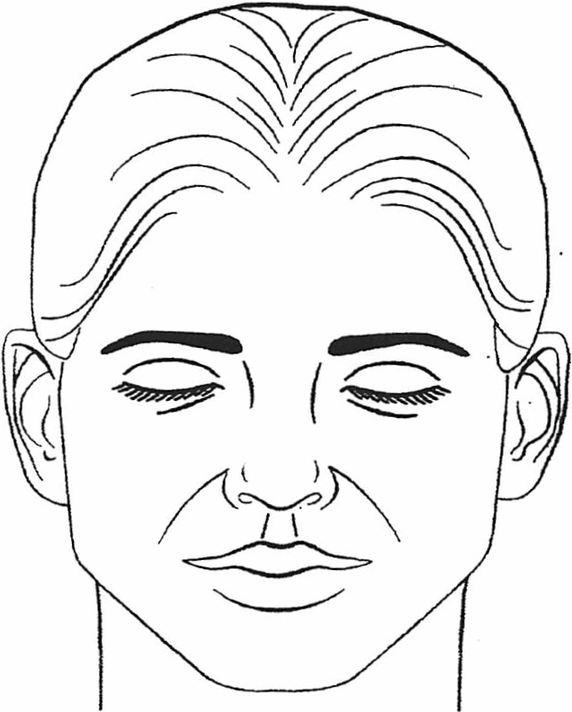
l Glabella

I I
(L) Orbicularis ocul i I
j (R) Orbicularis oculi ! !
I
I I
Obicularis Oris I
I
i I
; (L) Temporalis i '
I
l (R) Temporalis !

1 (L) Masseter
l
I
I
j (R) Masseter I
I I

Total units needed:

Co Ent form comp!ete?: Y ::J N :J

CC\ NSL'!.r YOUR ASSIG N ED FACULTY MEMBER LJPON COMPLETION OF THIS FORM BEFORE
TREATING YOUR PATIENT.
22

